[Java](https://www.geeksforgeeks.org/java/) is a pure [OOPS concept](https://www.geeksforgeeks.org/object-oriented-programming-oops-concept-in-java/) based programming language. Hence in Java, all the [variables](https://www.geeksforgeeks.org/variables-in-java/), data and the statements must be present in classes. These [classes](https://www.geeksforgeeks.org/understanding-classes-and-objects-in-java/) consist of both [constructors](https://www.geeksforgeeks.org/constructors-in-java/) and [methods](https://www.geeksforgeeks.org/methods-in-java/).

Methods and Constructors are different from each other in a lot of ways.

[Constructors](https://www.geeksforgeeks.org/constructors-in-java/):

Constructors are used to initialize the object’s state. Like [methods](https://www.geeksforgeeks.org/methods-in-java/), a constructor also contains **collection of statements(i.e. instructions)** that are executed at time of Object creation. Each time an object is created using **new()** keyword at least one constructor (it could be default constructor) is invoked to assign initial values to the **data members** of the same class.

// Java Program to illustrate constructor

import java.io.*;

class fullstack {

int num;

String name;

// This would be invoked while an object

// of that class created.

fullstack()

{

System.out.println("Constructor called");

}

}

class RS {

public static void main(String[] args)

{

// this would invoke default constructor.

fullstack obj1 = new fullstack();

// Default constructor provides the default

// values to the object like 0, null

System.out.println(obj1.name);

System.out.println(obj1.num);

}

}

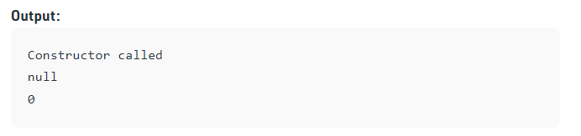

[Methods](https://www.geeksforgeeks.org/methods-in-java/):  
A method is a collection of statements that perform some specific task and return the result to the caller. A method can perform some specific task without returning anything. Methods allow us to reuse the code without retyping the code. In Java, every method must be part of some class which is different from languages like C, C++, and Python.

// Java Program to illustrate methods

import java.io.*;

class Addition {

int sum = 0;

public int addTwoInt(int a, int b)

{

// Adding two integer value.

sum = a + b;

// Returning summation of two values.

return sum;

}

}

class fullstack {

public static void main(String[] args)

{

// Creating an instance of Addition class

Addition add = new Addition();

// Calling addTwoInt() method

// to add two integer

// using instance created

// in above step.

int s = add.addTwoInt(1, 2);

System.out.println("Sum of two "

+ "integer values: "

+ s);}}

